California State Polytechnic University, Pomona

Lab 6: 16-bit Barrel Shifter/Rotator

Group F:

Danny Manzo, Bronco ID: 014451190

Maher Mateen, Bronco ID: 013891189

ECE 3101L – Signals and Systems Laboratory

Professor Mohamed Aly

25 July 2022

1. **How a Barrel Shifter/Rotator Works:**

A Barrel Shifter/Rotator is a combinational circuit that shifts or rotates the input by a specific number of bits. The Barrel Shifter is widely used in the real world application because it takes a single cycle to shift or rotate any amount of bits thus leading to more efficient code. It can be shifted from left to right, right to left, and it can be rotated in a single cycle. With the Barrel Shifter, we can use a sequence of multiplexers with a select input to create a cycle and shift bits.

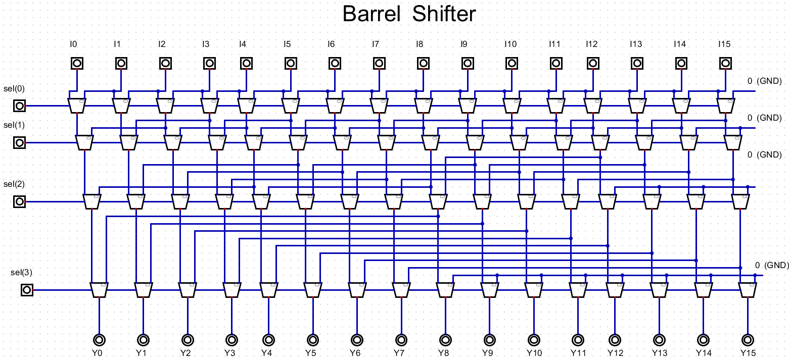

Figure 1: 16-bit Barrel Shifter

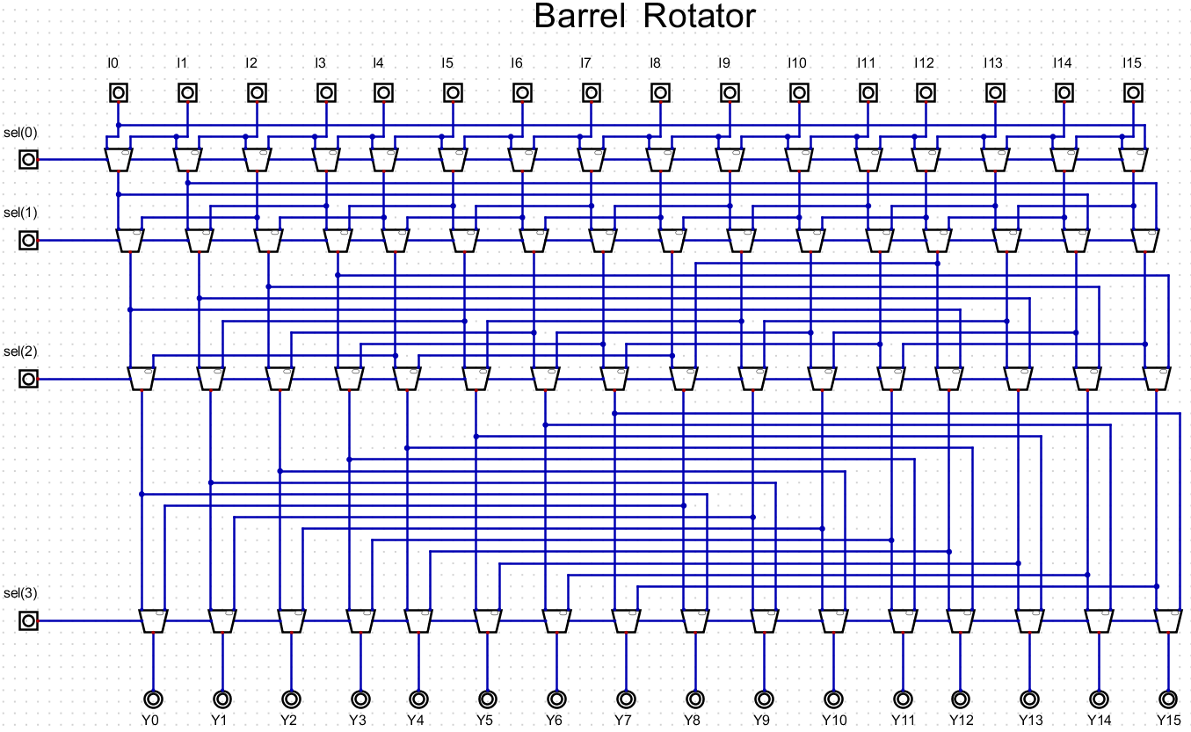

Figure 2: 16-bit Barrel Rotator

1. **How We Coded It:**

To code the Barrel Shifter, first we made a generic Barrel Shifter that can rotate/shift left/right. To shift left/right, we simply used the “<<” and “>>” which are logical shift operators. However, to rotate left/right, we made use of an OR operation of the two logical shift operators, shifting left by n bits and ORing that with the result of shifting right by (WIDTH - n bits) to rotate left and shifting right by n bits and ORing that with the result of shifting left by (WIDTH - n bits) to rotate right. Afterwards, we used the x7Seg code and Demux 1x2 code from previous labs and changed the input names accordingly. For determining how many bits we want to shift by, we used the counter made in previous labs as a base for our automatic mode, and changed the number of bits we want to shift by equating it to our current manual input for manual mode. Lastly, we put all these modules together in our BarrelShifter_top module, calling them appropriately as well as using code from previous labs to choose the digit being displayed, select the display to turn on, and switch between the 8 7-segment displays.

1. **Vivado Data Collection:**

In Vivado, after running the synthesis and report utilization, we found that there was 81 look-up tables (LUTs), 67 slice registers, 46 slices, 81 LUTs as logic, 12 LUT Flip Flop Pairs, 34 bonded input/output bits (IOB), and 2 BUFGCTRL. The total power of the barrel shifter was reported to be 0.105 W.

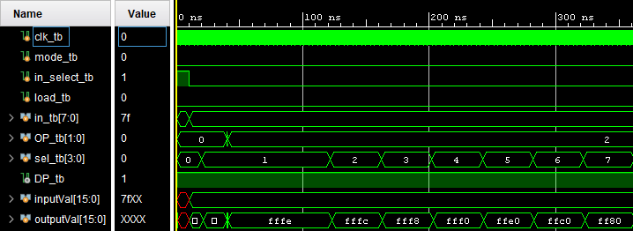

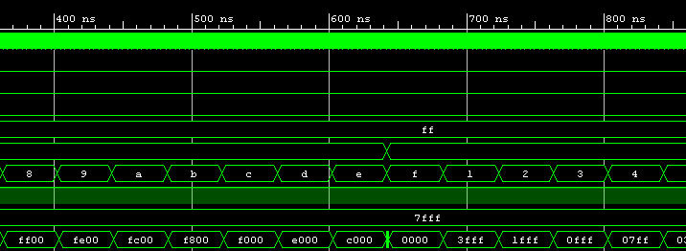

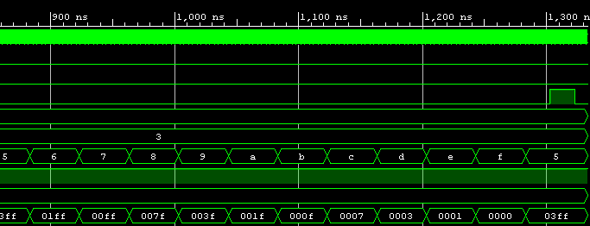

Figure 3: Testbench Results

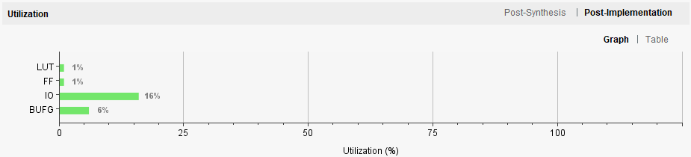

Figure 4: Resource Utilization Graph

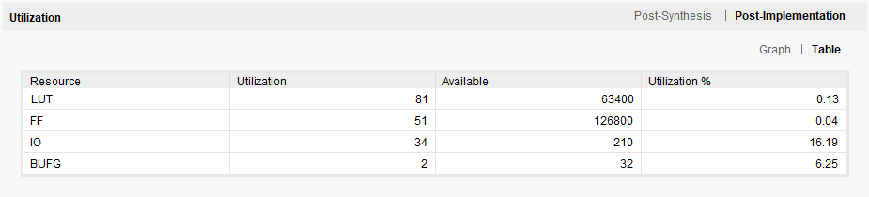

Figure 5: Resource Utilization Table 1

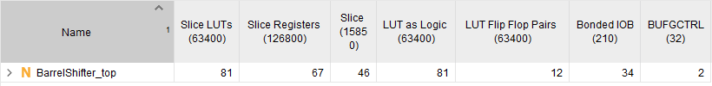

Figure 6: Resource Utilization Table 2

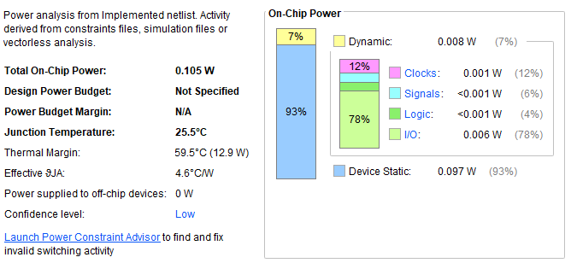

Figure 7: Power Usage